And in this lesson, we're going to be learning about a new concept called Variables and Their Data types In last lesson have learnt what the thing mean inside our script that can be inserted by default

The variables and data type are the most basic and most important things in computer programming. So from high school algebra, you guys know that variables are something in which we can store any value and we can hold any value. The same thing applies for computer programming here in unity and in C# specifically you can actually store any value inside a variable .As an example suppose we have to store the value 5 . So you create a variable with the name and you store the value five inside this. So that means you have the value five inside that variable. And whenever you want, you can use that name in place of that value. OK, so variables can be thought of, temporary places to put some value and use them anywhere in your program. OK, so the next thing going to learn is which goes hand in hand with variable. It's called data type. It means the type of data that you can store inside a variable. As an example, we have different types of data that you want to store. As an example, we may want to store the value of 55, which is a number. On the other hand, we also want to store of fifty five point five, which is a float number fifty. We may want to store any name like Raja, and that is a string, a pair of characters, a bunch of characters together. And we want to store a single character c so far to store this different kind of things, to store these different kind of data. We need different kind of data types. So there are different data types and the variable which is of certain data type. We can store values of those kind of values inside those kind of variables. So let's get started and check out some examples.

So first of all, suppose I want to store the value five inside a variable called a so I create a variable named a and then write 5 and we have to end this statement we write semicolon. So here what it means is that I'm putting this value five inside this variable a and one more thing we have to include is the data type of this variable since we are putting an integer value. So we have to mention that a is an integer type of variable inside which we are putting the value 5

3:25

Now to tell that you are storing an integer value in a variable we type int before variable name that is short for integer so that we can see that we have we are creating a variable and integer variable that is named as a and we are putting the value five inside it. So now it look like below

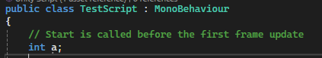

So whenever we want to use the value five, we can mention the value a and it will act as it has value of 5 So let's go and create some more if we want to create and store the value five point five which is a decimal point then we need different type that is float

So we write float b = 5.5f; and we have to mention the number that we are going to store is a float by writing F after the decimal point number which tells it is a float number not a double as shown below

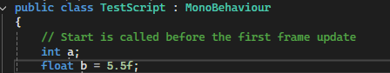

So here we are storing this five point five float value inside this variable B, which is a float. And then finally, suppose you want to store your name. So for storing names or string of characters, we have a special that are data type called string. So we write string and then the variable name that is myName and then set it to your name now it looks like below



Now in above you can see that the name have written is enclosed in double quotes . so whenever you were writing a bunch of characters together, you have to write double quotes. That means this is a string value.

So now, how would you believe us that these values are inside these variables. Teacher have said before that variables are just a temporary place to store values, but how will you believe but how will you believe us that a contains five, b contains five point five, myName contains “Jatin”. So let's go and bring them into the console and let's see what happens, as we have learned in the last lesson in order to print you have to write Debug.log to write the log and print it inside the console and lets say we pass a in Debig.log that means we are printing the value of a let's go and go to window console.

So our start method code look like below

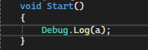

Now we open the Unity console by going to window and then in submenu go general and then to console

5:42

Clear the console so that the previous console is removed Now if we click on play button then see the console and since the debug.log is in start method so this code is called when the game runs and this code is called Now we run it you can see below 5 is written

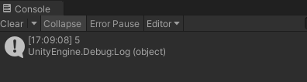

So that means inside a we have the value five and we have printing the value of a so five gets printed

Now if I pass myName variable (which is string type and inside it we have value Jatin)in the Debug.log. Now if we run the game again then you see my name is written in console as shown below

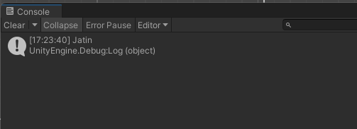

So this is the basic concept of variables and data types and suppose in your program. You have to use the value Five in many places. So you just write a in many places and it will it will seem that five is there. And if you want to change the value of 5 you can change it in marked below from 5 to 6

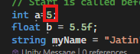

And the code will be same.

all over the code you've written. Suppose a lot of places you have written it. So if you have to change the value of a You don't need to change a with other variable or you don't remove a.

you just need to change in the value as marked above and the change will occur everywhere. So this is the facility that you get by using variables of different kind of data types.

We have learned the basic concept of data types in unity. See you in the next lesson.